WCES Kindergarten Weekly Homework Menu
DUE 3/9/23
http://wilsoncreekkindergarten.weebly.com/
Must Do:  Addition:  Solve the problems below. Write the equation/number sentence.  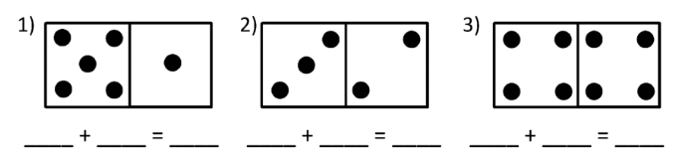  Can you make your own domino equation? | Writing:  Pick a long vowel o word (CVCe-silent e) from the read sheet on back and write a sentence. Illustrate your sentence. | Must Do:  Complete Kindergarten Read Sheet (on back)  - Review the long vowel o  - Read the long vowel o words. (CVCe-Silent e)  - Read the high frequency words.  - Read the sentences and highlight the high frequency words.  - Fill in the missing letters
Technology:  Practice logging on to iReady.  Practice for at least 20 min. (10 min math/10 min reading) Do not forget to log off correctly. | Every Night  Read for ten minutes! | Skip counting:  Practice skip counting by 10.  What are the missing numbers?
Cause and Effect:  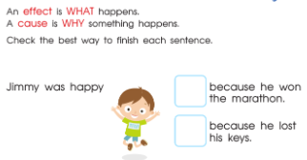 | Read Across America Week  What is your favorite book and tell the reasons why it is your favorite! | Pennies and dimes:  Count out 13 pennies to show 13 cents. Show 13 cents another way using pennies and dimes.
In addition to the “must do” squares, choose at least 3 additional squares to complete this week. Draw an X through the square once the task is complete! Sign and return the menu sheet on the above due date! Keep practice sheets at home.
Name: _________________________________________
Parent Signature: ________________________________

